Lecture 11

**Setting-Up-FTPs-in-Enterprise**

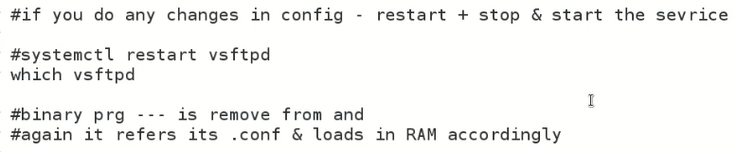

**Tip:-** if a service is showing *error* while we want to start it 🡪 *service is not starting*

* + 90% chances are that this is due to a problem with “.conf” file
* 3 types of users in FTP Server
  1. Anonymous
  2. Regular
  3. Virtual
* 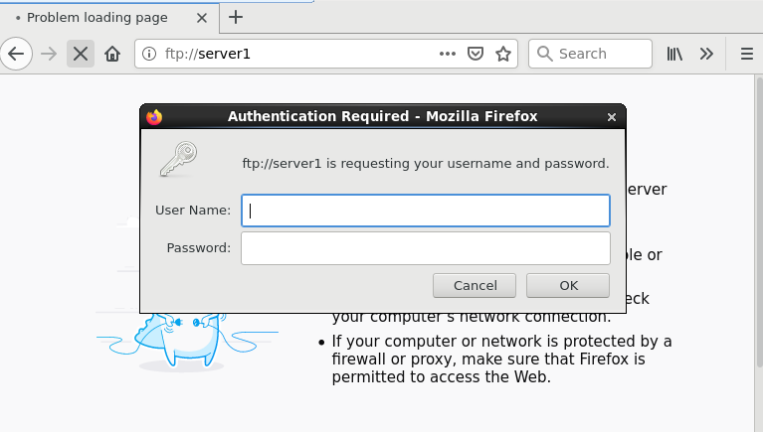
* It is asking for credentials of ***local users*** of Linux (FTP Server)
* 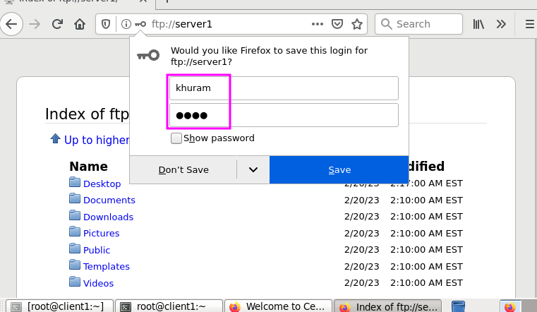
* I gave the credentials of local user and the files were visible
* It logs in to the “home directory” of that specific local user.

**How to access files on client through CLI?**

* 
* $ yum install ftp (here ftp is not for server, it is for FTP client)
* After installation
* $ ftp server1
* Text

  Description automatically generated
* Asking for Username & password
* After successful login
* It takes to ftp> console
* 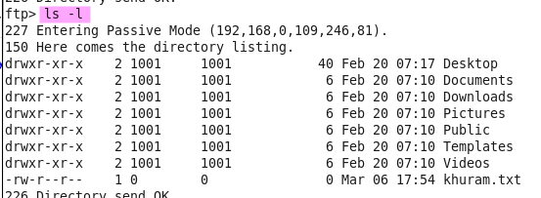
* Shows files at home directory
* ftp> help 🡪 shows available commands
* to download ,
* ftp> mget <file_name> ***to download***
* ftp> mput <file_name> ***to upload***
* ftp> bye 🡪 to exit
* if there is any issue stop SELinux
* 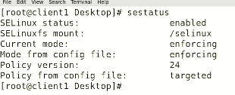
* $ setenforce 0 🡪 to stop SELinux 🡪 (Security-Enhanced Linux)
* ftp> is showing whole system’s (OS) directories which is not good and a vulnerability. 🡪 we need to restrict the user to the respective home directory.
* I received SELinux warning.
* 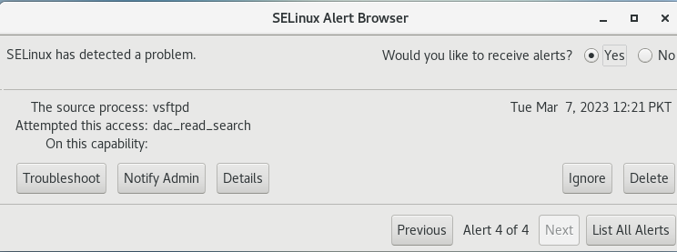
* And ignored it. But in vain,
* To disable it, 🡪 for the sake of R&D but it is not recommended.
* 
* Graphical user interface, text, application

  Description automatically generated
* 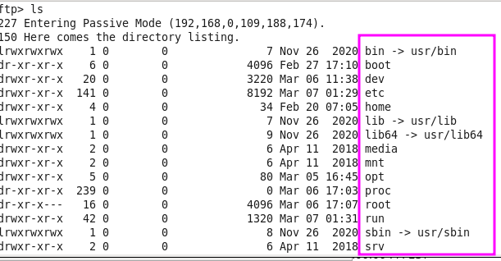
* **Solution**
* Graphical user interface

  Description automatically generated with low confidence
* Go to /etc/vsftpd and open “vsftpd” file with “vi editor”.
* Text

  Description automatically generated
* To reflect the changes,
  + $ systemctl restart vsftpd
  + But in production environment it is not a professional way to handle it, because restarting the service means all the connected users would disconnected, so the solution is “reload”
  + $ systemctl **reload** vsftpd
  + Working of reload 🡪 

How we setup and use **FTP** in an organization?

* 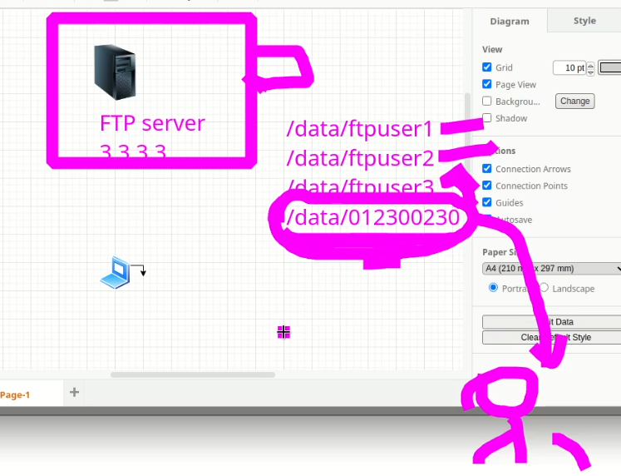
* 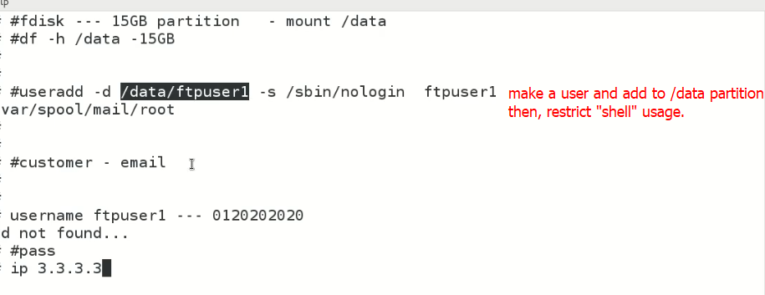
* Interview Question,
* What is difference b/w active ftp and passive ftp?
* The main difference between active FTP and passive FTP is how the FTP server and client establish the data connection during file transfers.
* In active FTP, the client initiates the control connection (port 21) to the server, and the server initiates a data connection (port 20) back to the client to transfer files. This means that the client's firewall must allow incoming connections on port 20. Active FTP can be problematic in situations where the client is behind a firewall or NAT (Network Address Translation) device, as the server may not be able to establish a data connection back to the client.
* In passive FTP, the client initiates both the control and data connections to the server. When the client requests a file transfer, the server responds with a port number to use for the data connection, and the client connects to that port. This means that passive FTP is more firewall-friendly, as the client initiates both connections and the firewall can be configured to allow incoming connections on the specific data port range used by the FTP server.
* In summary, active FTP requires the server to initiate a data connection back to the client, which can be problematic in certain firewall or NAT configurations, while passive FTP requires the client to initiate both the control and data connections, making it more firewall-friendly.
* 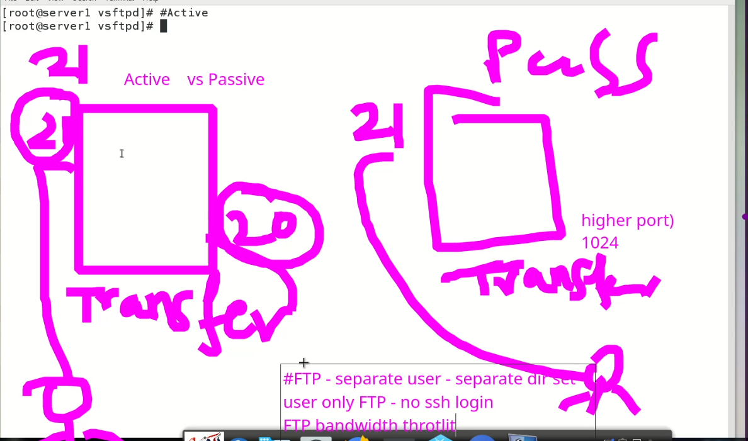
* .
* I face the issue while accessing the files after “Chroot” is set to YES
* I am not able to access files from user account,
* Here r some solutions,
* in vsftp I have edited "chroot" to restrict the user from accessting other files but after this change files are not accessible online
* When you set the "chroot" parameter in vsftpd, it restricts the user to their home directory and prevents them from accessing files outside of it. This is a common security measure to prevent unauthorized access to sensitive system files.
* If you have set "chroot_local_user=YES" in the vsftpd configuration file, then the users will be chrooted to their home directory upon login. However, this may cause issues with file access if the necessary files and directories are not present within the user's home directory.
* To fix this issue, you need to make sure that the necessary files and directories are present within the user's home directory. This includes any files or directories that the user needs to access online. If you have moved files to the user's home directory, make sure that their permissions are set correctly so that the user has access to them.
* You can also consider using the "allow_writeable_chroot=YES" option in the vsftpd configuration file if you want to allow users to create or upload files within their home directory while still being chrooted.
* If you are still having issues with file access after making these changes, you should check the vsftpd logs for any errors or messages that may provide more information about the issue.
* To view the vsftpd error log, you can check the default log file location specified in the vsftpd configuration file. The default location for the vsftpd log file is usually /var/log/vsftpd.log or /var/log/messages.